What is NoSQL?
NoSQL is a non-relational DBMS, that does not require a fixed schema, avoids joins, and is easy to scale. The purpose of using a NoSQL database is for distributed data stores with humongous data storage needs. NoSQL is used for Big data and real-time web apps. For example, companies like Twitter, Facebook, Google collect terabytes of user data every single day.
NoSQL database stands for "Not Only SQL" or "Not SQL." Though a better term would NoREL NoSQL caught on. Carl Strozz introduced the NoSQL concept in 1998.
Traditional RDBMS uses SQL syntax to store and retrieve data for further insights. Instead, a NoSQL database system encompasses a wide range of database technologies that can store structured, semi-structured, unstructured and polymorphic data.
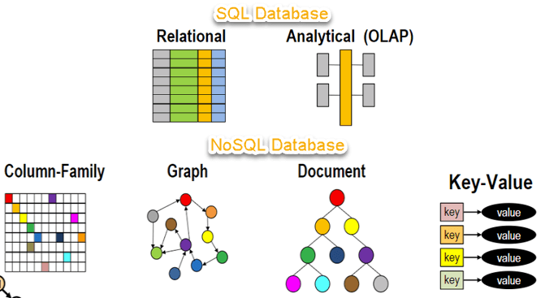

Why NoSQL?
The concept of NoSQL databases became popular with Internet giants like Google, Facebook, Amazon, etc. who deal with huge volumes of data. The system response time becomes slow when you use RDBMS for massive volumes of data.
To resolve this problem, we could "scale up" our systems by upgrading our existing hardware. This process is expensive.
The alternative for this issue is to distribute database load on multiple hosts whenever the load increases. This method is known as "scaling out."
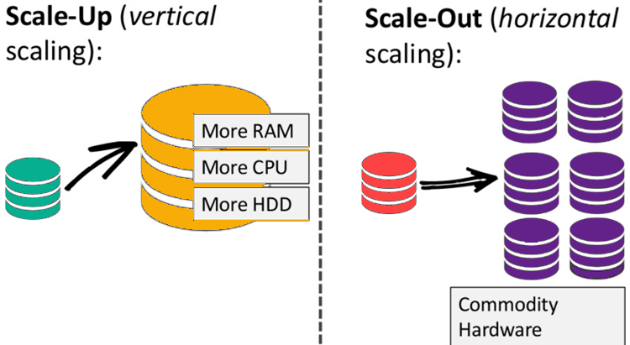
NoSQL database is non-relational, so it scales out better than relational databases as they are designed with web applications in mind.

Brief History of NoSQL Databases
- 1998- Carlo Strozzi use the term NoSQL for his lightweight, open-source relational database
- 2000- Graph database Neo4j is launched
- 2004- Google BigTable is launched
- 2005- CouchDB is launched
- 2007- The research paper on Amazon Dynamo is released
- 2008- Facebooks open sources the Cassandra project
- 2009- The term NoSQL was reintroduced

Features of NoSQL
Non-relational
- NoSQL databases never follow the relational model
- Never provide tables with flat fixed-column records
- Work with self-contained aggregates or BLOBs
- Doesn't require object-relational mapping and data normalization
- No complex features like query languages, query planners,
referential integrity joins, ACID
Schema-free
- NoSQL databases are either schema-free or have relaxed schemas
- Do not require any sort of definition of the schema of the data
- Offers heterogeneous structures of data in the same domain
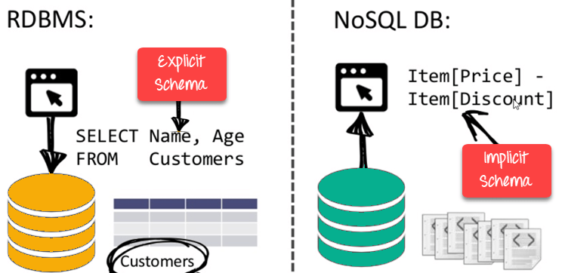

Simple API
- Offers easy to use interfaces for storage and querying data provided
- APIs allow low-level data manipulation & selection methods
- Text-based protocols mostly used with HTTP REST with JSON
- Mostly used no standard based query language
- Web-enabled databases running as internet-facing services
Distributed
- Multiple NoSQL databases can be executed in a distributed fashion
- Offers auto-scaling and fail-over capabilities
- Often ACID concept can be sacrificed for scalability and throughput
- Mostly no synchronous replication between distributed nodes Asynchronous Multi-Master Replication, peer-to-peer, HDFS Replication
- Only providing eventual consistency
- Shared Nothing Architecture. This enables less coordination and higher distribution.
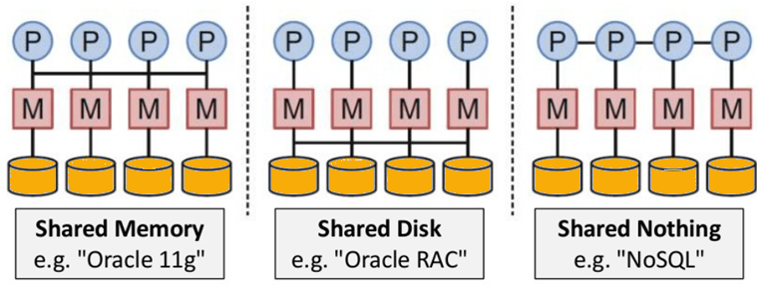
NoSQL is Shared Nothing.

Types of NoSQL Databases
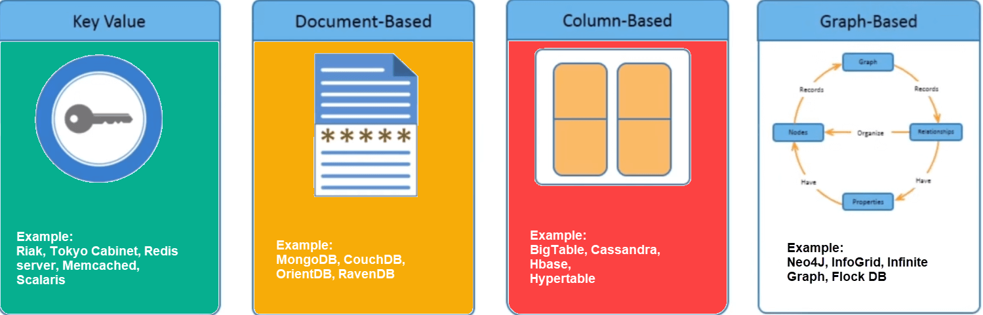
There are mainly four categories of NoSQL databases. Each of these categories has its unique attributes and limitations. No specific database is better to solve all problems. You should select a database based on your product needs.
Let see all of them:
- Key-value Pair Based
- Column-oriented Graph
- Graphs based
- Document-oriented

Key Value Pair Based

Data is stored in key/value pairs. It is designed in such a way to handle lots of data and heavy load.
Key-value pair storage databases store data as a hash table where each key is unique, and the value can be a JSON, BLOB(Binary Large Objects), string, etc.
For example, a key-value pair may contain a key like "Website" associated with a value like "Guru99".
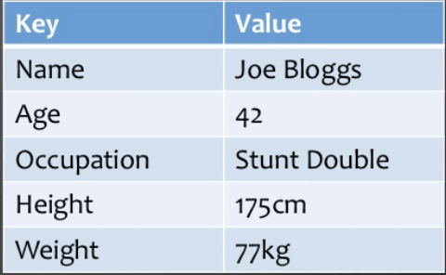
It is one of the most basic types of NoSQL databases. This kind of NoSQL database is used as a collection, dictionaries, associative arrays, etc. Key value stores help the developer to store schema-less data. They work best for shopping cart contents.
Redis, Dynamo, Riak are some examples of key-value store DataBases. They are all based on Amazon's Dynamo paper.

Column-based
Column-oriented databases work on columns and are based on BigTable paper by Google. Every column is treated separately. Values of single column databases are stored contiguously.
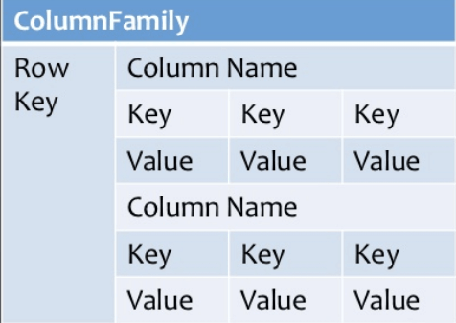
Column based NoSQL database
They deliver high performance on aggregation queries like SUM, COUNT, AVG, MIN etc. as the data is readily available in a column.
Column-based NoSQL databases are widely used to manage data warehouses, business intelligence, CRM, Library card catalogs,
HBase, Cassandra, HBase, Hypertable are examples of column based database.

Document-Oriented:
Document-Oriented NoSQL DB stores and retrieves data as a key value pair but the value part is stored as a document. The document is stored in JSON or XML formats. The value is understood by the DB and can be queried.
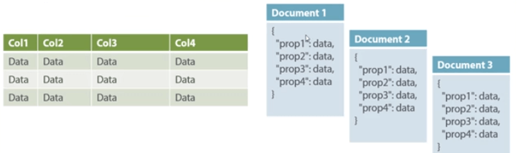
Relational Vs. Document
In this diagram on your left you can see we have rows and columns, and in the right, we have a document database which has a similar structure to JSON. Now for the relational database, you have to know what columns you have and so on. However, for a document database, you have data store like JSON object. You do not require to define which make it flexible.
The document type is mostly used for CMS systems, blogging platforms, real-time analytics & e-commerce applications. It should not use for complex transactions which require multiple operations or queries against varying aggregate structures.
Amazon SimpleDB, CouchDB, MongoDB, Riak, Lotus Notes, MongoDB, are popular Document originated DBMS systems.

Graph-Based
A graph type database stores entities as well the relations amongst those entities. The entity is stored as a node with the relationship as edges. An edge gives a relationship between nodes. Every node and edge has a unique identifier.
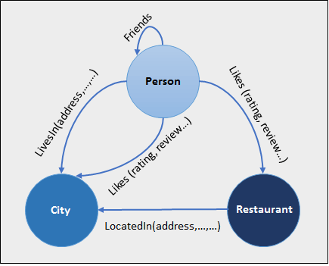
Compared to a relational database where tables are loosely connected, a Graph database is a multi-relational in nature. Traversing relationship is fast as they are already captured into the DB, and there is no need to calculate them.
Graph base database mostly used for social networks, logistics, spatial data.

Query Mechanism tools for NoSQL
The most common data retrieval mechanism is the REST-based retrieval of a value based on its key/ID with GET resource
Document store Database offers more difficult queries as they understand the value in a key-value pair. For example, CouchDB allows defining views with MapReduce

What is the CAP Theorem?
CAP theorem is also called brewer's theorem. It states that is impossible for a distributed data store to offer more than two out of three guarantees
- Consistency
- Availability
- Partition Tolerance
Consistency:
The data should remain consistent even after the execution of an operation. This means once data is written, any future read request should contain that data. For example, after updating the order status, all the clients should be able to see the same data.
Availability:
The database should always be available and responsive. It should not have any downtime.
Partition Tolerance:
Partition Tolerance means that the system should continue to function even if the communication among the servers is not stable. For example, the servers can be partitioned into multiple groups which may not communicate with each other. Here, if part of the database is unavailable, other parts are always unaffected.

Eventual Consistency
The term "eventual consistency" means to have copies of data on multiple machines to get high availability and scalability. Thus, changes made to any data item on one machine has to be propagated to other replicas.
Data replication may not be instantaneous as some copies will be updated immediately while others in due course of time. These copies may be mutually, but in due course of time, they become consistent. Hence, the name eventual consistency.
BASE: Basically Available, Soft state, Eventual consistency
- Basically, available means DB is available all the time as per CAP theorem
- Soft state means even without an input; the system state may change
- Eventual consistency means that the system will become consistent over time
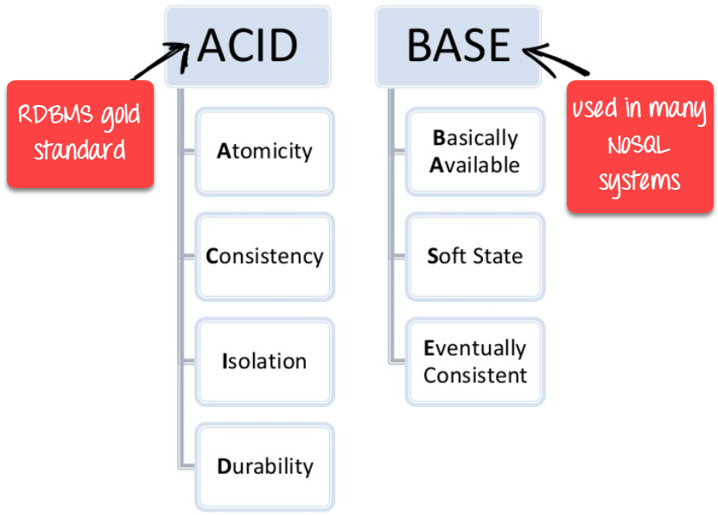

Advantages of NoSQL
- Can be used as Primary or Analytic Data Source
- Big Data Capability
- No Single Point of Failure
- Easy Replication
- No Need for Separate Caching Layer
- It provides fast performance and horizontal scalability.
- Can handle structured, semi-structured, and unstructured data with equal effect
- Object-oriented programming which is easy to use and flexible
- NoSQL databases don't need a dedicated high-performance server
- Support Key Developer Languages and Platforms
- Simple to implement than using RDBMS
- It can serve as the primary data source for online applications.
- Handles big data which manages data velocity, variety, volume, and complexity
- Excels at distributed database and multi-data center operations
- Eliminates the need for a specific caching layer to store data
- Offers a flexible schema design which can easily be altered without downtime or service disruption

Disadvantages of NoSQL
- No standardization rules
- Limited query capabilities
- RDBMS databases and tools are comparatively mature
- It does not offer any traditional database capabilities, like consistency when multiple transactions are performed simultaneously.
- When the volume of data increases it is difficult to maintain unique values as keys become difficult
- Doesn't work as well with relational data
- The learning curve is stiff for new developers
- Open source options so not so popular for enterprises.

Summary
- NoSQL is a non-relational DMS, that does not require a fixed schema, avoids joins, and is easy to scale
- The concept of NoSQL databases beccame popular with Internet giants like Google, Facebook, Amazon, etc. who deal with huge volumes of data
- In the year 1998- Carlo Strozzi use the term NoSQL for his lightweight, open-source relational database
- NoSQL databases never follow the relational model it is either schema-free or has relaxed schemas
- Four types of NoSQL Database are 1).Key-value Pair Based 2).Column-oriented Graph 3). Graphs based 4).Document-oriented
- NOSQL can handle structured, semi-structured, and unstructured data with equal effect
- CAP theorem consists of three words Consistency, Availability, and Partition Tolerance
- BASE stands for Basically Available, Soft state, Eventual consistency
- The term "eventual consistency" means to have copies of data on multiple machines to get high availability and scalability
- NOSQL offer limited query capabilities

